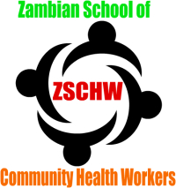

Certified
NURSING ASSISTANT
training
Entry
Duration
Site
Start
Apply

In person

Email
Net
Phone
Grade 12, including English
9 months
Subdivision K288a, Makeni-Konga
3rd July, 2013
Application form KR100 / Fee KR50

From ZSCHW Ltd
Rm 9, 9th floor
FINDECO House
Cairo Rd, Lusaka
P.O. Box 37865, Lusaka
Tel +260 211235549

Email zschwlusaka@gmail.com
Download from www.zschw.weebly.com
Zanaco, branch CRBC A/c No. 0400440000002576

0967476614 / 0977806134 / 0964657487

